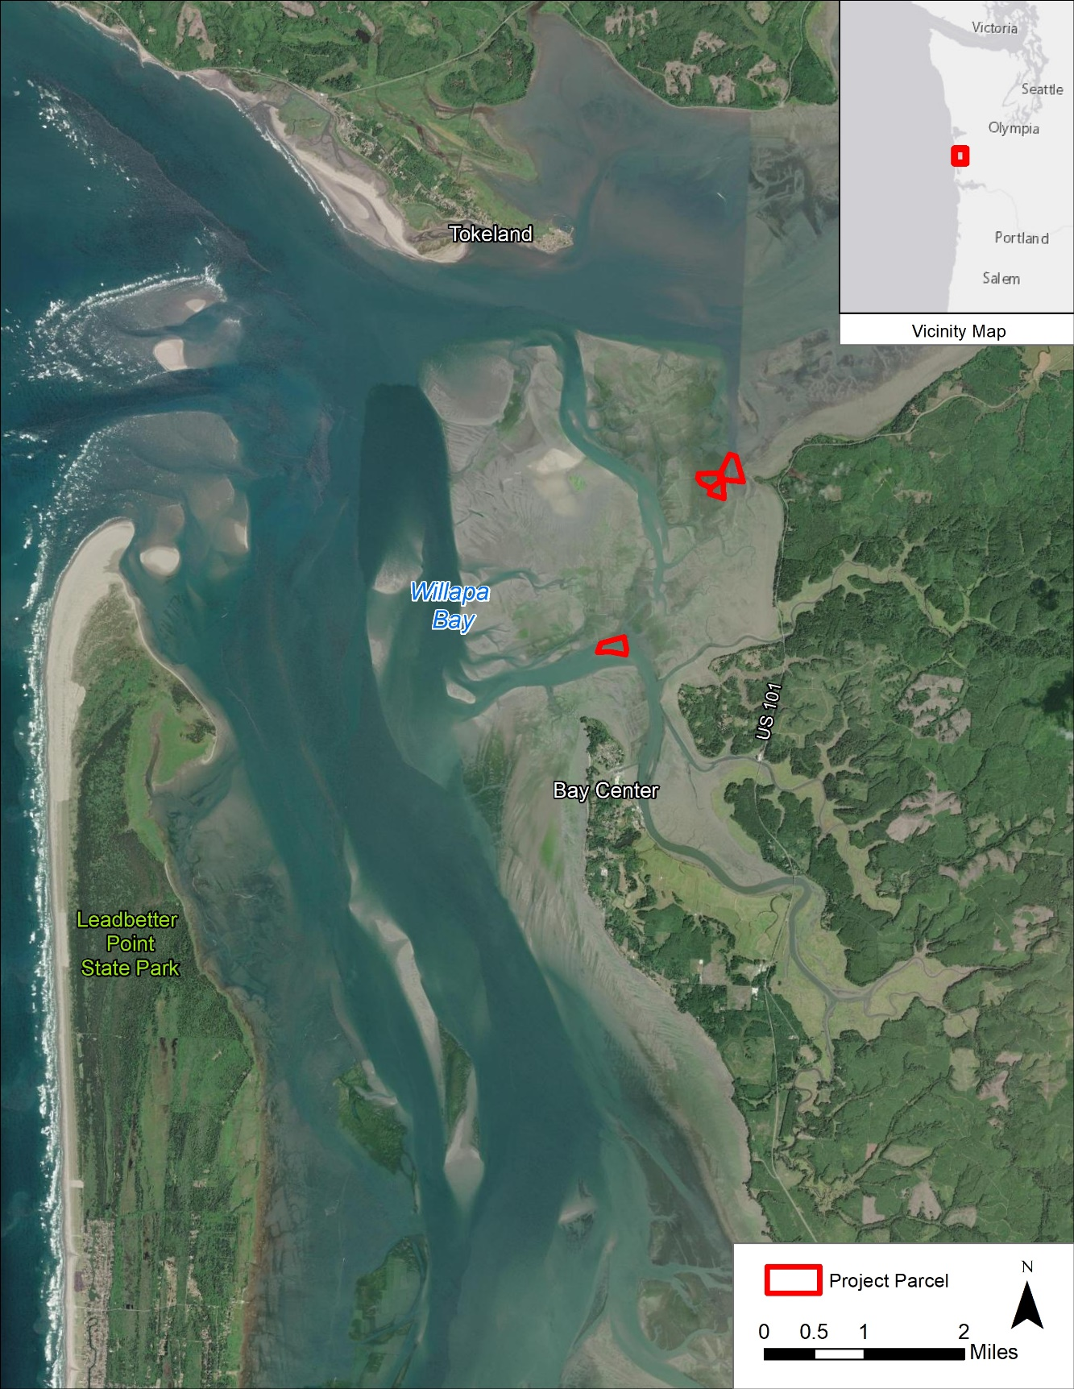

|  |  |  |
| --- | --- | --- |
| EXAMPLE: VICINITY MAP | | |
| CORPS REFERENCE: Add NWS Number  APPLICANT: Add Name | PARCEL IDs/Owners:  Add parcel number(s) and parcel owner(s) | PROPOSED PROJECT:  Name of the Project/Farm  Sheet 1 of 3  Date: Date |
| SITE ADDRESS:  Add Water Body (no street address)  City, State Zip  In: Add Water Body  County: County  State: State |
| ADJACENT PROPERTY OWNERS (West to East):  Refer to Attachment C or add list if there is enough room | Tidal Datum: NA  Scale: 1:80,000  Coordinate System: WA State Plan South (feet) |