EXAMPLE: CROSS SECTION VIEW
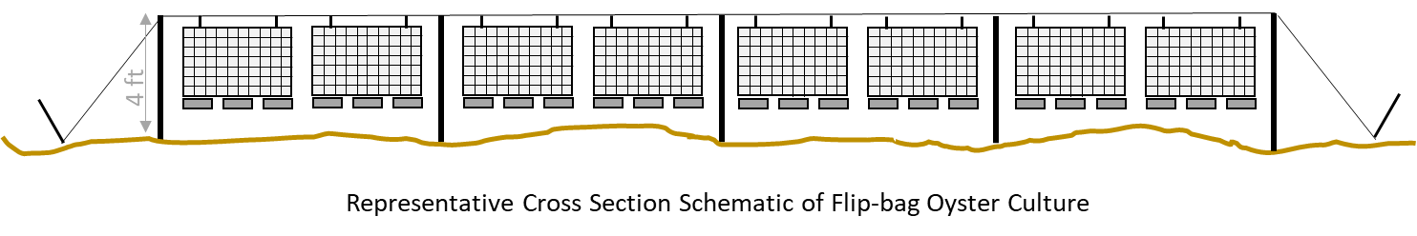
CORPS REFERENCE: Add NWS Number  APPLICANT: Add Name | PARCEL IDs/Owners:  Add parcel number(s) and parcel owner(s) | PROPOSED PROJECT:  Name of the Project/Farm  Sheet 3 of 3  Date: Date
SITE ADDRESS:
Add Water Body (no street address)
City, State Zip

In: Add Water Body
County: County
State: State
 | ADJACENT PROPERTY OWNERS (West to East):  Refer to Attachment C or add list if there is enough room | Tidal Datum: NA  Scale: NA  Coordinate System: NA

